KWSO Washanaksha Grant Project 2016  Multimedia Shaptakai:  Art Interpretations of Tribal History  PROPOSAL FORM | 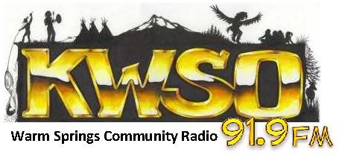

Contact Information
Name
Street Address
City ST ZIP Code
Home Phone
Work Phone
E-Mail Address

Medium
For the artwork you propose – what medium will you use?
Pencil | Paint
Pen & Ink | Electronic/Digital
Marker | Other (please list)

Description of historic moment or cultural practice

Talk about the scene you will create and how you will do research or develop the depiction.

Please include a sketch of what you are proposing for this project. If possible, also include photos or copies of other artwork you have created.

You can submit more than one proposal but need to complete one of these forms for each submission.
Artwork for chosen proposals must be 11’ x 14’ in size at a minimum.

Proposal forms can be dropped off at the Media Center or emailed to kwso@wstribes.org
Proposals are due no later than 5pm Friday March 19th.

Artists who are selected will be interviewed by KWSO about the project.

Artwork chosen becomes the property of KWSO.

Please sign her to indicate you understand the guidelines for this proposal and if selected will submit the completed artwork by April 30, 2016.
Name (printed)
Signature
Date

