CULTURE AND HERITAGE LANGUAGE CLASS
SIGN-UPS FOR WSK8 SCHOOL YEAR 2021-2022

The Culture & Heritage Language Program will be teaching the three languages Ichishkin, Kiksht, and Numu at the WSK8 Academy for the 2021/2022 school year. Please specify which language you would like your child (ren) to learn.

“Research shows that learning a second language boosts problem-solving, critical thinking, and listening skills, in addition to improving memory, concentration, and the ability to multitask. Children proficient in other languages also show signs of enhanced creativity and mental flexibility.”

Parent / Guardian:
Email address:
Phone number:

Warm Springs Language = Ichishkin (ICH)
Wasq’u Language = Kiksht (KIK)
Paiute Language = Numu (NUM)

STUDENTS NAME | GRADE | ICH | KIK | NUM
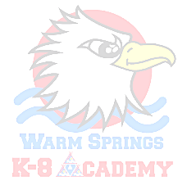

PLEASE RETURN TO CULTURE & HERITAGE DROP BOX IN FRONT OF EDUCATION BUILDING OR EMAIL TO radine.johnson@wstribes.org
Contact for information: 541 553-3290

